How does AI work?
To begin with, an AI system accepts data input in the form of speech, text, image, etc. The system then processes data by applying various rules and algorithms, interpreting, predicting, and acting on the input data. Upon processing, the system provides an outcome, i.e., success or failure, on data input. The result is then assessed through analysis, discovery, and feedback. Lastly, the system uses its assessments to adjust input data, rules and algorithms, and target outcomes. This loop continues until the desired result is achieved.
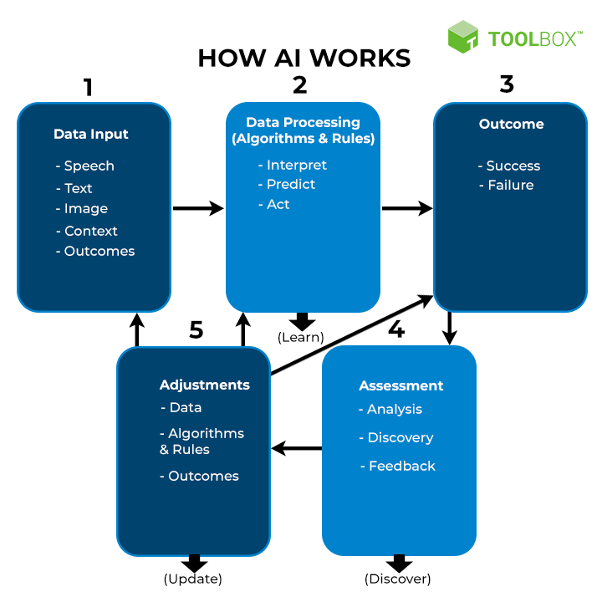

Key components of AI
Intelligence has a broader context that reflects a deeper capability to comprehend the surroundings. However, for it to qualify as AI, all its components need to work in conjunction with each other. Let’s understand the key components of AI.
- 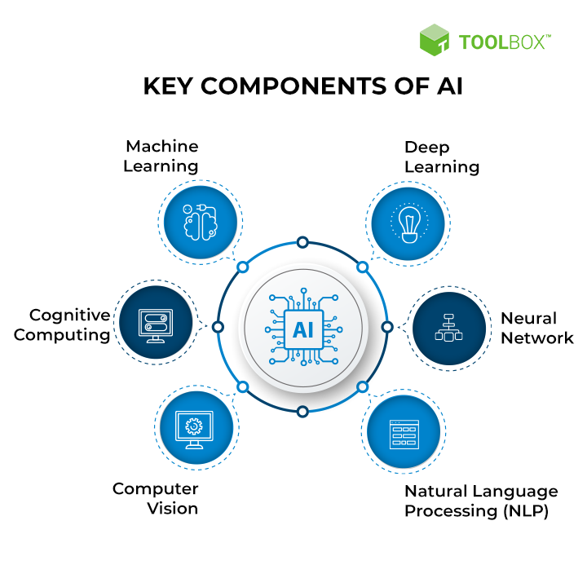 Machine learning: Machine learning is an AI application that automatically learns and improves from previous sets of experiences without the requirement for explicit programming.
- Deep learning: Deep learning is a subset of ML that learns by processing data with the help of artificial neural networks.
- Neural network: Neural networks are computer systems that are loosely modeled on neural connections in the human brain and enable deep learning.
- Cognitive computing: Cognitive computing aims to recreate the human thought process in a computer model. It seeks to imitate and improve the interaction between humans and machines by understanding human language and the meaning of images.
- Natural language processing (NLP): NLP is a tool that allows computers to comprehend, recognize, interpret, and produce human language and speech.
- Computer vision: Computer vision employs deep learning and pattern identification to interpret image content (graphs, tables, PDF pictures, and videos).

